**VISVESVARAYA TECHNOLOGICAL UNIVERSITY**

“Jnana Sangama”, Belagavi – 590 018, Karnataka



**MINI PROJECT REPORT**

**ON**

“Employee Database”

***Submitted in partial fulfillment of the requirements for the***

***Mobile Application Development Lab (18CSMP68)***

**BACHELOR OF ENGINEERING**

**IN**

**COMPUTER SCIENCE & ENGINEERING**

*Submitted by:*

**RAGHAVENDRA P : 1JT19CS066**

under the guidance of

NAGARAJ. A

Associate Professor

Department of Computer Science and Engineering



Department of Computer Science and Engineering Jyothy Institute of Technology

Tataguni, Off. Kanakapura Road,

Bengaluru – 560 082

**2021 – 2022**

JYOTHY INSTITUTE OF TECHNOLOGY

Department of Computer Science and Engineering

Accredited by NBA, New Delhi

Tataguni, Off. Kanakapura Road, Bengaluru - 560 082



C E R T I F I C A T E

This is to certify that the Mini Project titled '**Employee Database’ carried** out by **Mr/Ms** RAGHAVENDRA P, **USN:** 1JT19CS066, a Bonafede student of Jyothy Institute of Technology, in partial fulfillment for the award of  **Bachelor of Engineering**, in  **Computer Science and Engineering** under Visvesvaraya Technological University, Belagavi, during the year 2021- 2022.

The project report has been approved, as it satisfies the academic requirements in respect of Mini Project prescribed for the course Mobile Application Development Lab (18CSMP68).

Signature of Faculty Incharge Signature of HOD

.................................... .…..............................

Prof. Nagaraj. A Dr. Prabhanjan. S.

Associate Professor Prof & Head of Dept - CSE

Dept of CSE JIT, Bengaluru JIT, Bengaluru

External Viva

Name of the Examiners Signature with Date

1)

2)

D E C L A R A T I O N

I, RAGHAVENDRA P, 6th Semester student of Computer Science and Engineering, Jyothy Institute of Technology, Bangalore - 560 082, declare that the Mini Project of Mobile Application Development Lab (18CSMP68) is successfully completed.

This report is submitted in partial fulfillment of the requirements for award of Bachelor Degree in Computer Science and Engineering, during the academic year 2021-2022.

Date : 15-07-2022

Place : Bangalore

USN : 1JT19CS066

Name : RAGHAVENDRA P

A C K N O W L E D G E M E N T

This Mini Project is a result of accumulated guidance, direction and support of several important persons. I take this opportunity to express my gratitude to all, who have helped us to complete the Mini Project.

I express our sincere thanks to our Principal Dr K. Gopalakrishna, for providing us adequate facilities to undertake this Mini Project.

I would like to thank Dr. Prabhanjan. S, Head of Dept - CSE, for providing us an opportunity to carry out Mini Project and for his valuable guidance and support.

I would like to thank, Prof. Nagaraj. A, Faculty In Charge, for guiding us during the period of Mini Project.

I would like to thank all the faculty members of CSE department for the support extended during the course of Mini Project.

I would like to thank the non-teaching members of the Dept of CSE, for helping us during the Mini Project.

Last but not the least, I would like to thank our parents and friends without whose constant help, the completion of Mini Project would have not been possible.

**RAGHAVENDRA P [ 1JT19CS066 ]**

Table of Contents

|  |  |  |
| --- | --- | --- |
| **Sr No** | **Description** | **Page No** |
| 01 | Problem statement with input and output diagram | 7 |
| 02 | XML files code | 9 |
| 03 | Java files code | 19 |
| 04 | Screen shots | 29 |

**CHAPTER 1**

**Problem statement**

**with**

**input and output diagram**

Problem Statement:

Develop an android application – Employee database application that helps the user to manage Employees by adding Employees, deleting Employees by ID, searching Employees by ID, update and display all Employees in form of a list.

Input and Output Diagram:

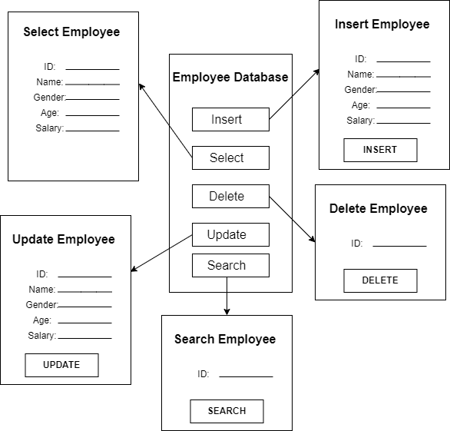

**CHAPTER 2**

**XML files Code**

activity_main.xml:

<?xml version="1.0" encoding="utf-8"?>

<androidx.constraintlayout.widget.ConstraintLayout xmlns:android="http://schemas.android.com/apk/res/android"

xmlns:app="http://schemas.android.com/apk/res-auto"

xmlns:tools="http://schemas.android.com/tools"

android:layout_width="match_parent"

android:layout_height="match_parent"

tools:context=".MainActivity">

<TextView

android:id="@+id/textView"

android:layout_width="wrap_content"

android:layout_height="wrap_content"

android:layout_marginTop="44dp"

android:text="Employee Database"

android:textSize="40dp"

app:layout_constraintEnd_toEndOf="parent"

app:layout_constraintStart_toStartOf="parent"

app:layout_constraintTop_toTopOf="parent" />

<TextView

android:id="@+id/textView2"

android:layout_width="wrap_content"

android:layout_height="wrap_content"

android:layout_marginTop="24dp"

android:text="CRUD Operations"

android:textSize="30dp"

app:layout_constraintEnd_toEndOf="parent"

app:layout_constraintStart_toStartOf="parent"

app:layout_constraintTop_toBottomOf="@+id/textView" />

<Button

android:id="@+id/btn_insert"

android:layout_width="wrap_content"

android:layout_height="wrap_content"

android:layout_marginTop="72dp"

android:text="INSERT"

app:layout_constraintEnd_toEndOf="parent"

app:layout_constraintHorizontal_bias="0.498"

app:layout_constraintStart_toStartOf="parent"

app:layout_constraintTop_toBottomOf="@+id/textView2" />

<Button

android:id="@+id/btn_update"

android:layout_width="wrap_content"

android:layout_height="wrap_content"

android:layout_marginTop="56dp"

android:text="Update"

app:layout_constraintEnd_toEndOf="parent"

app:layout_constraintStart_toStartOf="parent"

app:layout_constraintTop_toBottomOf="@+id/btn_insert" />

<Button

android:id="@+id/btn_delete"

android:layout_width="wrap_content"

android:layout_height="wrap_content"

android:layout_marginTop="52dp"

android:text="DELETE"

app:layout_constraintEnd_toEndOf="parent"

app:layout_constraintHorizontal_bias="0.507"

app:layout_constraintStart_toStartOf="parent"

app:layout_constraintTop_toBottomOf="@+id/btn_update" />

<Button

android:id="@+id/btn_select"

android:layout_width="96dp"

android:layout_height="52dp"

android:layout_marginTop="44dp"

android:layout_marginEnd="144dp"

android:text="Select All"

app:layout_constraintEnd_toEndOf="parent"

app:layout_constraintTop_toBottomOf="@+id/btn_delete" />

</androidx.constraintlayout.widget.ConstraintLayout>

activity_list.xml:

<?xml version="1.0" encoding="utf-8"?>

<LinearLayout xmlns:android="http://schemas.android.com/apk/res/android"

xmlns:app="http://schemas.android.com/apk/res-auto"

xmlns:tools="http://schemas.android.com/tools"

android:layout_width="match_parent"

android:layout_height="match_parent"

android:orientation="vertical"

android:gravity="center_horizontal"

tools:context=".ListActivity">

<ListView

android:layout_width="match_parent"

android:layout_height="wrap_content"

android:layout_weight="1"

android:id="@+id/users_list"/>

</LinearLayout>

activity_delete.xml:

*<?xml version="1.0" encoding="utf-8"?>*

*<androidx.constraintlayout.widget.ConstraintLayout xmlns:android="http://schemas.android.com/apk/res/android"*

*xmlns:app="http://schemas.android.com/apk/res-auto"*

*xmlns:tools="http://schemas.android.com/tools"*

*android:layout_width="match_parent"*

*android:layout_height="match_parent"*

*tools:context=".DeleteActivity">*

*<TextView*

*android:id="@+id/textView8"*

*android:layout_width="wrap_content"*

*android:layout_height="wrap_content"*

*android:layout_marginTop="240dp"*

*android:text="Employee ID:"*

*android:textSize="20dp"*

*app:layout_constraintEnd_toEndOf="parent"*

*app:layout_constraintHorizontal_bias="0.145"*

*app:layout_constraintStart_toStartOf="parent"*

*app:layout_constraintTop_toTopOf="parent" />*

*<EditText*

*android:id="@+id/editText_id"*

*android:layout_width="wrap_content"*

*android:layout_height="wrap_content"*

*android:layout_marginTop="224dp"*

*android:layout_marginEnd="16dp"*

*android:ems="10"*

*android:hint="Enter ID"*

*android:inputType="textPersonName"*

*app:layout_constraintEnd_toEndOf="parent"*

*app:layout_constraintTop_toTopOf="parent" />*

*<Button*

*android:id="@+id/button_delete"*

*android:layout_width="wrap_content"*

*android:layout_height="wrap_content"*

*android:layout_marginBottom="280dp"*

*android:text="DELETE"*

*app:layout_constraintBottom_toBottomOf="parent"*

*app:layout_constraintEnd_toEndOf="parent"*

*app:layout_constraintHorizontal_bias="0.495"*

*app:layout_constraintStart_toStartOf="parent" />*

*</androidx.constraintlayout.widget.ConstraintLayout>*

search_activity.xml:

<?*xml version*="1.0" *encoding*="utf-8"?>  
<androidx.constraintlayout.widget.ConstraintLayout *xmlns:android*="http://schemas.android.com/apk/res/android"  
 *xmlns:app*="http://schemas.android.com/apk/res-auto"  
 *xmlns:tools*="http://schemas.android.com/tools"  
 *android:layout_width*="match_parent"  
 *android:layout_height*="match_parent">  
  
 <EditText  
 *android:id*="@+id/findText"  
 *android:layout_width*="wrap_content"  
 *android:layout_height*="wrap_content"  
 *android:layout_marginTop*="384dp"  
 *android:layout_marginEnd*="100dp"  
 *android:ems*="10"  
 *android:inputType*="textPersonName"  
 *android:minHeight*="48dp"  
 *android:text*="Name"  
 *app:layout_constraintEnd_toEndOf*="parent"  
 *app:layout_constraintTop_toTopOf*="parent" />  
  
 <Button  
 *android:id*="@+id/button"  
 *android:layout_width*="wrap_content"  
 *android:layout_height*="wrap_content"  
 *android:layout_marginTop*="472dp"  
 *android:layout_marginEnd*="152dp"  
 *android:text*="GET DATA"  
 *app:layout_constraintEnd_toEndOf*="parent"  
 *app:layout_constraintTop_toTopOf*="parent" />  
  
 <androidx.cardview.widget.CardView  
 *android:layout_width*="386dp"  
 *android:layout_height*="325dp"  
 *app:layout_constraintEnd_toEndOf*="parent"  
 *app:layout_constraintStart_toStartOf*="parent"  
 *app:layout_constraintTop_toTopOf*="parent">  
 <RelativeLayout  
 *xmlns:android*="http://schemas.android.com/apk/res/android"  
 *xmlns:tools*="http://schemas.android.com/tools"  
 *android:layout_width*="match_parent"  
 *android:layout_height*="match_parent"  
 *tools:context*=".SearchActivity">  
  
 <androidx.recyclerview.widget.RecyclerView  
 *android:id*="@+id/idRVItems"  
 *android:layout_width*="385dp"  
 *android:layout_height*="match_parent" />  
 </RelativeLayout>  
 </androidx.cardview.widget.CardView>  
  
</androidx.constraintlayout.widget.ConstraintLayout>

inserty_activity.xml:

<?xml version="1.0" encoding="utf-8"?>

<androidx.constraintlayout.widget.ConstraintLayout xmlns:android="http://schemas.android.com/apk/res/android"

xmlns:app="http://schemas.android.com/apk/res-auto"

xmlns:tools="http://schemas.android.com/tools"

android:layout_width="match_parent"

android:layout_height="match_parent"

tools:context=".InsertActivity">

<TextView

android:id="@+id/textView7"

android:layout_width="wrap_content"

android:layout_height="wrap_content"

android:layout_marginTop="60dp"

android:text="Salary"

android:textSize="20dp"

app:layout_constraintEnd_toEndOf="parent"

app:layout_constraintHorizontal_bias="0.07"

app:layout_constraintStart_toStartOf="parent"

app:layout_constraintTop_toBottomOf="@+id/textView6" />

<EditText

android:id="@+id/editText_salary"

android:layout_width="wrap_content"

android:layout_height="wrap_content"

android:layout_marginTop="364dp"

android:ems="10"

android:hint="Enter Salary"

android:inputType="textPersonName"

app:layout_constraintEnd_toEndOf="parent"

app:layout_constraintHorizontal_bias="0.583"

app:layout_constraintStart_toEndOf="@+id/textView4"

app:layout_constraintTop_toTopOf="parent" />

<TextView

android:id="@+id/textView6"

android:layout_width="wrap_content"

android:layout_height="wrap_content"

android:layout_marginTop="56dp"

android:text="Age"

android:textSize="20dp"

app:layout_constraintEnd_toEndOf="parent"

app:layout_constraintHorizontal_bias="0.122"

app:layout_constraintStart_toStartOf="parent"

app:layout_constraintTop_toBottomOf="@+id/textView5" />

<EditText

android:id="@+id/editText_age"

android:layout_width="wrap_content"

android:layout_height="wrap_content"

android:layout_marginTop="284dp"

android:ems="10"

android:hint="Enter Age"

android:inputType="textPersonName"

app:layout_constraintEnd_toEndOf="parent"

app:layout_constraintHorizontal_bias="0.777"

app:layout_constraintStart_toEndOf="@+id/textView4"

app:layout_constraintTop_toTopOf="parent" />

<EditText

android:id="@+id/editText_gender"

android:layout_width="wrap_content"

android:layout_height="wrap_content"

android:layout_marginTop="204dp"

android:ems="10"

android:hint="Enter Gender"

android:inputType="textPersonName"

app:layout_constraintEnd_toEndOf="parent"

app:layout_constraintHorizontal_bias="0.583"

app:layout_constraintStart_toEndOf="@+id/textView4"

app:layout_constraintTop_toTopOf="parent" />

<TextView

android:id="@+id/textView5"

android:layout_width="wrap_content"

android:layout_height="wrap_content"

android:layout_marginTop="60dp"

android:text="Gender"

android:textSize="20dp"

app:layout_constraintEnd_toEndOf="parent"

app:layout_constraintHorizontal_bias="0.106"

app:layout_constraintStart_toStartOf="parent"

app:layout_constraintTop_toBottomOf="@+id/textView4" />

<TextView

android:id="@+id/textView4"

android:layout_width="wrap_content"

android:layout_height="wrap_content"

android:layout_marginTop="124dp"

android:text="Employee Name"

android:textSize="20dp"

app:layout_constraintEnd_toEndOf="parent"

app:layout_constraintHorizontal_bias="0.06"

app:layout_constraintStart_toStartOf="parent"

app:layout_constraintTop_toTopOf="parent" />

<EditText

android:id="@+id/editText_name"

android:layout_width="wrap_content"

android:layout_height="wrap_content"

android:layout_marginTop="116dp"

android:ems="10"

android:hint="Enter Name"

android:inputType="textPersonName"

app:layout_constraintEnd_toEndOf="parent"

app:layout_constraintHorizontal_bias="0.555"

app:layout_constraintStart_toEndOf="@+id/textView4"

app:layout_constraintTop_toTopOf="parent" />

<Button

android:id="@+id/button_update"

android:layout_width="wrap_content"

android:layout_height="wrap_content"

android:layout_marginBottom="212dp"

android:text="INSERT"

app:layout_constraintBottom_toBottomOf="parent"

app:layout_constraintEnd_toEndOf="parent"

app:layout_constraintHorizontal_bias="0.442"

app:layout_constraintStart_toStartOf="parent" />

</androidx.constraintlayout.widget.ConstraintLayout>

update activity.xml:

<?xml version="1.0" encoding="utf-8"?>

<androidx.constraintlayout.widget.ConstraintLayout xmlns:android="http://schemas.android.com/apk/res/android"

xmlns:app="http://schemas.android.com/apk/res-auto"

xmlns:tools="http://schemas.android.com/tools"

android:layout_width="match_parent"

android:layout_height="match_parent"

tools:context=".UpdateActivity">

<TextView

android:id="@+id/textView8"

android:layout_width="wrap_content"

android:layout_height="wrap_content"

android:layout_marginTop="120dp"

android:text="ID"

android:textSize="20dp"

app:layout_constraintEnd_toEndOf="parent"

app:layout_constraintHorizontal_bias="0.045"

app:layout_constraintStart_toStartOf="parent"

app:layout_constraintTop_toBottomOf="@+id/textView6" />

<EditText

android:id="@+id/editText_id"

android:layout_width="wrap_content"

android:layout_height="wrap_content"

android:layout_marginTop="424dp"

android:ems="10"

android:hint="Enter ID"

android:inputType="textPersonName"

app:layout_constraintEnd_toEndOf="parent"

app:layout_constraintHorizontal_bias="0.615"

app:layout_constraintStart_toEndOf="@+id/textView4"

app:layout_constraintTop_toTopOf="parent" />

<TextView

android:id="@+id/textView7"

android:layout_width="wrap_content"

android:layout_height="wrap_content"

android:layout_marginTop="60dp"

android:text="Salary"

android:textSize="20dp"

app:layout_constraintEnd_toEndOf="parent"

app:layout_constraintHorizontal_bias="0.045"

app:layout_constraintStart_toStartOf="parent"

app:layout_constraintTop_toBottomOf="@+id/textView6" />

<EditText

android:id="@+id/editText_salary"

android:layout_width="wrap_content"

android:layout_height="wrap_content"

android:layout_marginTop="364dp"

android:ems="10"

android:hint="Enter Salary"

android:inputType="textPersonName"

app:layout_constraintEnd_toEndOf="parent"

app:layout_constraintHorizontal_bias="0.583"

app:layout_constraintStart_toEndOf="@+id/textView4"

app:layout_constraintTop_toTopOf="parent" />

<TextView

android:id="@+id/textView6"

android:layout_width="wrap_content"

android:layout_height="wrap_content"

android:layout_marginTop="48dp"

android:text="Age"

android:textSize="20dp"

app:layout_constraintEnd_toEndOf="parent"

app:layout_constraintHorizontal_bias="0.087"

app:layout_constraintStart_toStartOf="parent"

app:layout_constraintTop_toBottomOf="@+id/textView5" />

<EditText

android:id="@+id/editText_age"

android:layout_width="wrap_content"

android:layout_height="wrap_content"

android:layout_marginTop="284dp"

android:ems="10"

android:hint="Enter Age"

android:inputType="textPersonName"

app:layout_constraintEnd_toEndOf="parent"

app:layout_constraintHorizontal_bias="0.777"

app:layout_constraintStart_toEndOf="@+id/textView4"

app:layout_constraintTop_toTopOf="parent" />

<EditText

android:id="@+id/editText_gender"

android:layout_width="wrap_content"

android:layout_height="wrap_content"

android:layout_marginTop="204dp"

android:ems="10"

android:hint="Enter Gender"

android:inputType="textPersonName"

app:layout_constraintEnd_toEndOf="parent"

app:layout_constraintHorizontal_bias="0.583"

app:layout_constraintStart_toEndOf="@+id/textView4"

app:layout_constraintTop_toTopOf="parent" />

<TextView

android:id="@+id/textView5"

android:layout_width="wrap_content"

android:layout_height="wrap_content"

android:layout_marginTop="60dp"

android:text="Gender"

android:textSize="20dp"

app:layout_constraintEnd_toEndOf="parent"

app:layout_constraintHorizontal_bias="0.072"

app:layout_constraintStart_toStartOf="parent"

app:layout_constraintTop_toBottomOf="@+id/textView4" />

<TextView

android:id="@+id/textView4"

android:layout_width="wrap_content"

android:layout_height="wrap_content"

android:layout_marginTop="132dp"

android:text="Employee Name"

android:textSize="20dp"

app:layout_constraintEnd_toEndOf="parent"

app:layout_constraintHorizontal_bias="0.06"

app:layout_constraintStart_toStartOf="parent"

app:layout_constraintTop_toTopOf="parent" />

<EditText

android:id="@+id/editText_name"

android:layout_width="wrap_content"

android:layout_height="wrap_content"

android:layout_marginTop="116dp"

android:ems="10"

android:hint="Enter Name"

android:inputType="textPersonName"

app:layout_constraintEnd_toEndOf="parent"

app:layout_constraintHorizontal_bias="0.555"

app:layout_constraintStart_toEndOf="@+id/textView4"

app:layout_constraintTop_toTopOf="parent" />

<Button

android:id="@+id/button_update"

android:layout_width="wrap_content"

android:layout_height="wrap_content"

android:layout_marginBottom="144dp"

android:text="UPDATE"

app:layout_constraintBottom_toBottomOf="parent"

app:layout_constraintEnd_toEndOf="parent"

app:layout_constraintHorizontal_bias="0.459"

app:layout_constraintStart_toStartOf="parent" />

</androidx.constraintlayout.widget.ConstraintLayout>

**CHAPTER 3**

**Java files Code**

MainActivity.java:

*package com.example.madminiprj;*

*import androidx.appcompat.app.AppCompatActivity;*

*import android.content.Intent;*

*import android.os.Bundle;*

*import android.view.View;*

*import android.widget.Button;*

*public class MainActivity extends AppCompatActivity {*

*DatabaseHelper myDb;*

*Button btn_insert;*

*Button btn_update;*

*Button btn_delete;*

*Button btn_select;*

*@Override*

*protected void onCreate(Bundle savedInstanceState) {*

*super.onCreate(savedInstanceState);*

*setContentView(R.layout.activity_main);*

*myDb = new DatabaseHelper(this);*

*btn_insert = (Button) findViewById(R.id.btn_insert);*

*btn_insert.setOnClickListener(new View.OnClickListener() {*

*@Override*

*public void onClick(View v) {*

*openInsertActivity();*

*}*

*});*

*btn_update = (Button) findViewById(R.id.btn_update);*

*btn_update.setOnClickListener(new View.OnClickListener() {*

*@Override*

*public void onClick(View v) {*

*openUpdateActivity();*

*}*

*});*

*btn_delete = (Button) findViewById(R.id.btn_delete);*

*btn_delete.setOnClickListener(new View.OnClickListener() {*

*@Override*

*public void onClick(View v) {*

*openDeleteActivity();*

*}*

*});*

*btn_select = (Button) findViewById(R.id.btn_select);*

*btn_select.setOnClickListener(new View.OnClickListener() {*

*@Override*

*public void onClick(View v) {*

*openSelectActivity();*

*}*

*});*

*}*

*public void openInsertActivity() {*

*Intent intent = new Intent(this, InsertActivity.class);*

*startActivity(intent);*

*}*

*public void openUpdateActivity() {*

*Intent intent = new Intent(this, UpdateActivity.class);*

*startActivity(intent);*

*}*

*public void openDeleteActivity() {*

*Intent intent = new Intent(this, DeleteActivity.class);*

*startActivity(intent);*

*}*

*public void openSelectActivity() {*

*Intent intent = new Intent(this, ListActivity.class);*

*startActivity(intent);*

*}*

*}*

DatabaseHelper.java:

*package com.example.madminiprj;*

*import androidx.appcompat.app.AppCompatActivity;*

*import android.content.Intent;*

*import android.os.Bundle;*

*import android.view.View;*

*import android.widget.Button;*

*public class MainActivity extends AppCompatActivity {*

*DatabaseHelper myDb;*

*Button btn_insert;*

*Button btn_update;*

*Button btn_delete;*

*Button btn_select;*

*@Override*

*protected void onCreate(Bundle savedInstanceState) {*

*super.onCreate(savedInstanceState);*

*setContentView(R.layout.activity_main);*

*myDb = new DatabaseHelper(this);*

*btn_insert = (Button) findViewById(R.id.btn_insert);*

*btn_insert.setOnClickListener(new View.OnClickListener() {*

*@Override*

*public void onClick(View v) {*

*openInsertActivity();*

*}*

*});*

*btn_update = (Button) findViewById(R.id.btn_update);*

*btn_update.setOnClickListener(new View.OnClickListener() {*

*@Override*

*public void onClick(View v) {*

*openUpdateActivity();*

*}*

*});*

*btn_delete = (Button) findViewById(R.id.btn_delete);*

*btn_delete.setOnClickListener(new View.OnClickListener() {*

*@Override*

*public void onClick(View v) {*

*openDeleteActivity();*

*}*

*});*

*btn_select = (Button) findViewById(R.id.btn_select);*

*btn_select.setOnClickListener(new View.OnClickListener() {*

*@Override*

*public void onClick(View v) {*

*openSelectActivity();*

*}*

*});*

*}*

*public void openInsertActivity() {*

*Intent intent = new Intent(this, InsertActivity.class);*

*startActivity(intent);*

*}*

*public void openUpdateActivity() {*

*Intent intent = new Intent(this, UpdateActivity.class);*

*startActivity(intent);*

*}*

*public void openDeleteActivity() {*

*Intent intent = new Intent(this, DeleteActivity.class);*

*startActivity(intent);*

*}*

*public void openSelectActivity() {*

*Intent intent = new Intent(this, ListActivity.class);*

*startActivity(intent);*

*}*

*}*

InsertActivity.java:

*package com.example.madminiprj;*

*import androidx.appcompat.app.AlertDialog;*

*import androidx.appcompat.app.AppCompatActivity;*

*import android.database.Cursor;*

*import android.os.Bundle;*

*import android.view.View;*

*import android.widget.Button;*

*import android.widget.EditText;*

*import android.widget.Toast;*

*public class InsertActivity extends AppCompatActivity {*

*DatabaseHelper myDb;*

*EditText editName, editGender, editAge, editSalary;*

*Button btnAddData;*

*@Override*

*protected void onCreate(Bundle savedInstanceState) {*

*super.onCreate(savedInstanceState);*

*setContentView(R.layout.activity_insert);*

*myDb = new DatabaseHelper(this);*

*editName = (EditText) findViewById(R.id.editText_name);*

*editGender = (EditText) findViewById(R.id.editText_gender);*

*editAge = (EditText) findViewById(R.id.editText_age);*

*editSalary = (EditText) findViewById(R.id.editText_salary);*

*btnAddData = (Button) findViewById(R.id.button_update);*

*AddData();*

*}*

*public void AddData() {*

*btnAddData.setOnClickListener(new View.OnClickListener() {*

*@Override*

*public void onClick(View v) {*

*boolean isInserted = myDb.insertData(editName.getText().toString(),*

*editGender.getText().toString(),*

*editAge.getText().toString(),*

*editSalary.getText().toString() );*

*if(isInserted == true)*

*Toast.makeText(InsertActivity.this,"Data Inserted", Toast.LENGTH_LONG).show();*

*else*

*Toast.makeText(InsertActivity.this,"Data is NOT Inserted", Toast.LENGTH_LONG).show();*

*}*

*});*

*}*

*}*

UpdateActivity.java:

*package com.example.madminiprj;*

*import androidx.appcompat.app.AlertDialog;*

*import androidx.appcompat.app.AppCompatActivity;*

*import android.database.Cursor;*

*import android.os.Bundle;*

*import android.view.View;*

*import android.widget.Button;*

*import android.widget.EditText;*

*import android.widget.Toast;*

*public class UpdateActivity extends AppCompatActivity {*

*DatabaseHelper myDb;*

*Button btnUpdate;*

*EditText editId;*

*EditText editName, editGender, editAge, editSalary;*

*@Override*

*protected void onCreate(Bundle savedInstanceState) {*

*super.onCreate(savedInstanceState);*

*setContentView(R.layout.activity_update);*

*myDb = new DatabaseHelper(this);*

*editName = (EditText) findViewById(R.id.editText_name);*

*editGender = (EditText) findViewById(R.id.editText_gender);*

*editAge = (EditText) findViewById(R.id.editText_age);*

*editSalary = (EditText) findViewById(R.id.editText_salary);*

*editId = (EditText) findViewById(R.id.editText_id);*

*btnUpdate = (Button) findViewById(R.id.button_update);*

*UpdateData();*

*}*

*public void UpdateData() {*

*btnUpdate .setOnClickListener(new View.OnClickListener() {*

*@Override*

*public void onClick(View v) {*

*boolean isUpdate = myDb.updateData(editId.getText().toString(), editName.getText().toString(),editGender.getText().toString()*

*,editAge.getText().toString(),editSalary.getText().toString()); //this will get text,convert to string and pass it to this fn.*

*if(isUpdate == true)*

*Toast.makeText(UpdateActivity.this,"Data Updated Succesfully", Toast.LENGTH_LONG).show();*

*else*

*Toast.makeText(UpdateActivity.this,"Data is NOT Updated", Toast.LENGTH_LONG).show();*

*}*

*});*

*}*

*}*

ListActivity.java:

*package com.example.madminiprj;*

*import androidx.appcompat.app.AppCompatActivity;*

*import android.database.Cursor;*

*import android.os.Bundle;*

*import android.view.View;*

*import android.widget.AdapterView;*

*import android.widget.ArrayAdapter;*

*import android.widget.ListView;*

*import android.widget.Toast;*

*import java.util.ArrayList;*

*public class ListActivity extends AppCompatActivity {*

*DatabaseHelper myDb;*

*ListView userlist;*

*ArrayList<String> listItem;*

*ArrayAdapter adapter;*

*@Override*

*protected void onCreate(Bundle savedInstanceState) {*

*super.onCreate(savedInstanceState);*

*setContentView(R.layout.activity_list);*

*myDb = new DatabaseHelper(this);*

*listItem = new ArrayList<>();*

*userlist =findViewById(R.id.users_list);*

*viewData();*

*userlist.setOnItemClickListener(new AdapterView.OnItemClickListener() {*

*@Override*

*public void onItemClick(AdapterView<?> adapterView, View view, int i, long l) {*

*String text = userlist.getItemAtPosition(i).toString();*

*Toast.makeText(ListActivity.this, ""+text, Toast.LENGTH_SHORT).show();*

*}*

*});*

*}*

*private void viewData() {*

*Cursor cursor = myDb.viewData();*

*if (cursor.getCount() == 0) {*

*Toast.makeText(this, "No Data to show", Toast.LENGTH_SHORT).show();*

*}*

*else {*

*while (cursor.moveToNext()) {*

*listItem.add("ID:" + cursor.getString(0) );*

*listItem.add("Name:" + cursor.getString(1) );*

*listItem.add("Gender:" + cursor.getString(2) );*

*listItem.add("Age:" + cursor.getString(3) );*

*listItem.add("Salary:" + cursor.getString(4) +"\n\n\n");*

*}*

*adapter = new ArrayAdapter<>(this, android.R.layout.simple_list_item_1, listItem);*

*userlist.setAdapter(adapter);*

*}*

*}*

*}*

DeleteActivity.java:

*package com.example.madminiprj;*

*import androidx.appcompat.app.AlertDialog;*

*import androidx.appcompat.app.AppCompatActivity;*

*import android.content.Intent;*

*import android.database.Cursor;*

*import android.os.Bundle;*

*import android.view.View;*

*import android.widget.Button;*

*import android.widget.EditText;*

*import android.widget.Toast;*

*public class DeleteActivity extends AppCompatActivity {*

*DatabaseHelper myDb;*

*Button btnDelete;*

*EditText editId;*

*@Override*

*protected void onCreate(Bundle savedInstanceState) {*

*super.onCreate(savedInstanceState);*

*setContentView(R.layout.activity_delete);*

*myDb = new DatabaseHelper(this);*

*editId = (EditText) findViewById(R.id.editText_id);*

*btnDelete = (Button) findViewById(R.id.button_delete);*

*DeleteData();*

*}*

*public void DeleteData() {*

*btnDelete.setOnClickListener(new View.OnClickListener() {*

*@Override*

*public void onClick(View v) {*

*Integer deletedRows = myDb.deleteData(editId.getText().toString());*

*if(deletedRows > 0)*

*Toast.makeText(DeleteActivity.this,"Data Deleted Succesfully", Toast.LENGTH_LONG).show();*

*else*

*Toast.makeText(DeleteActivity.this,"Data is NOT Deleted", Toast.LENGTH_LONG).show();*

*}*

*});*

*}*

*}*

**CHAPTER 4**

**Screen Shots**

**Screenshots:**

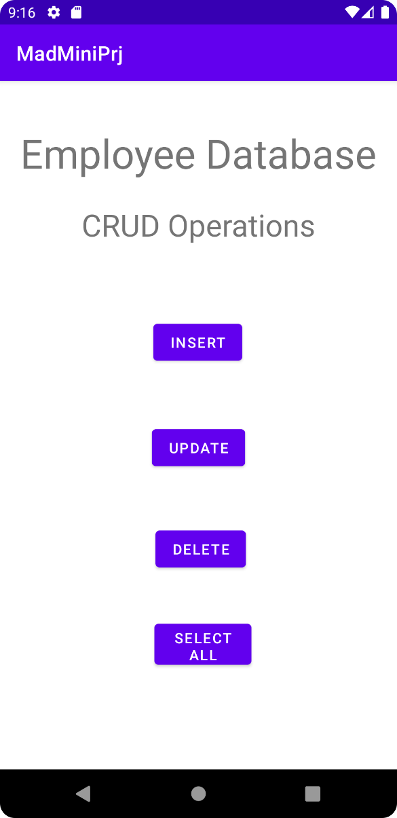 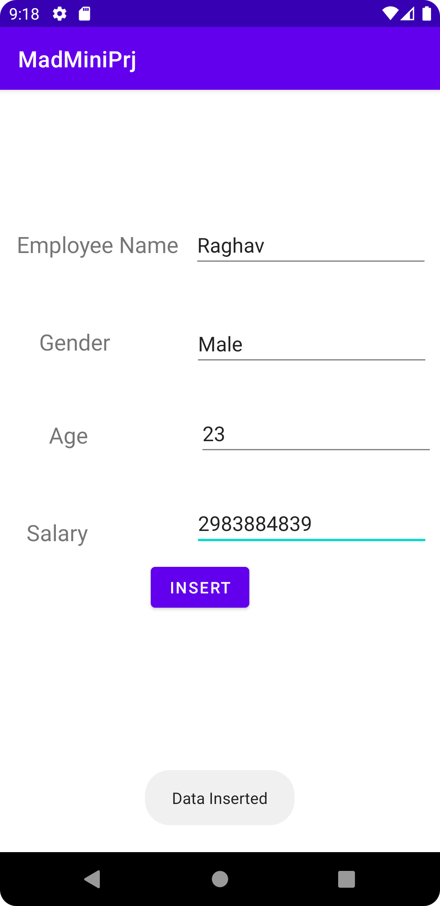

**Home page Successful Insertion**

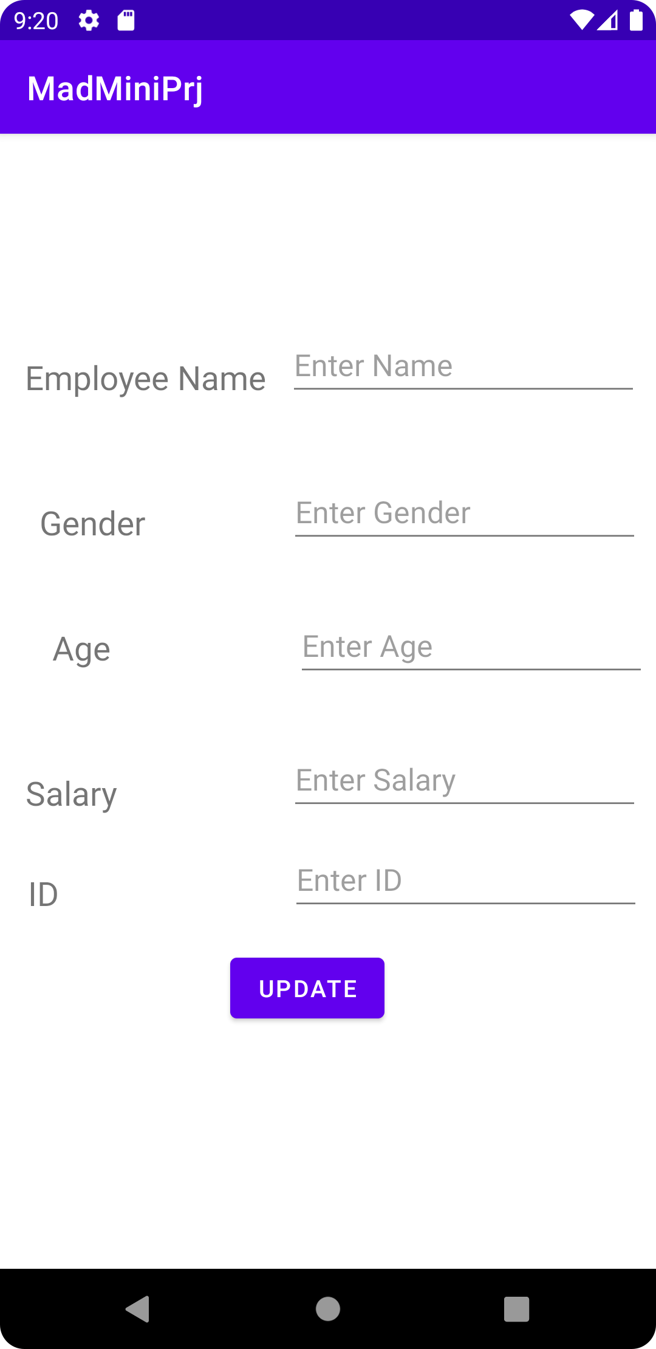 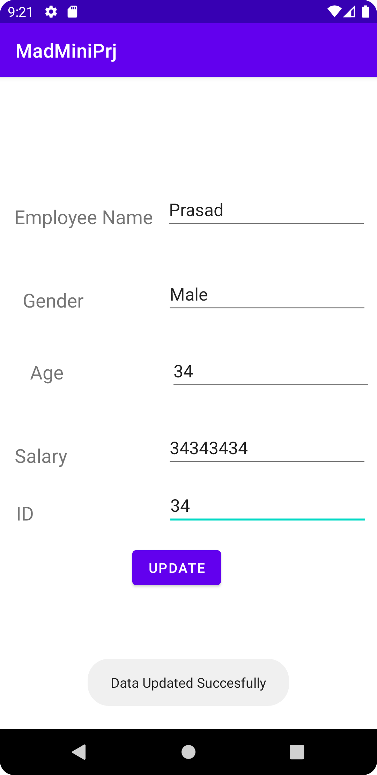

**Update page Successfully updated**

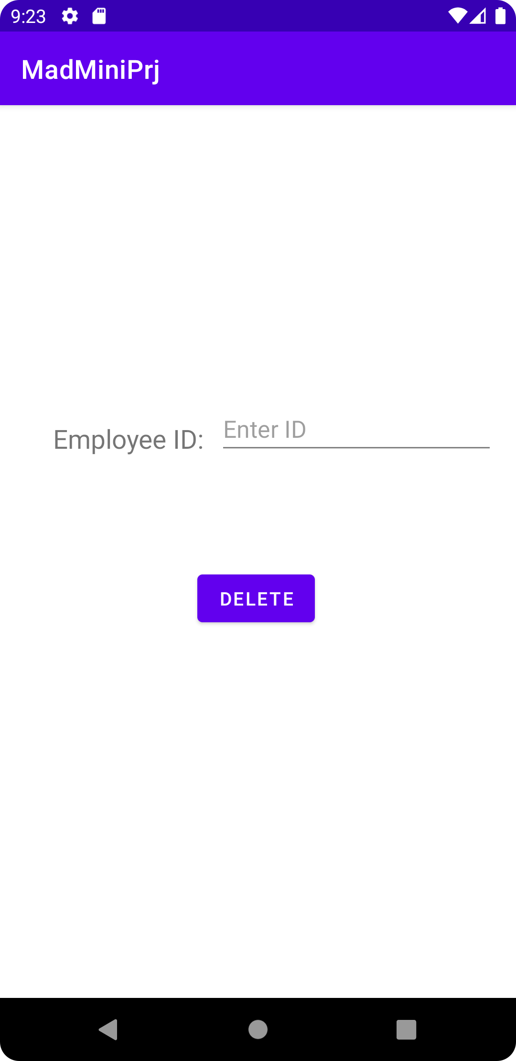 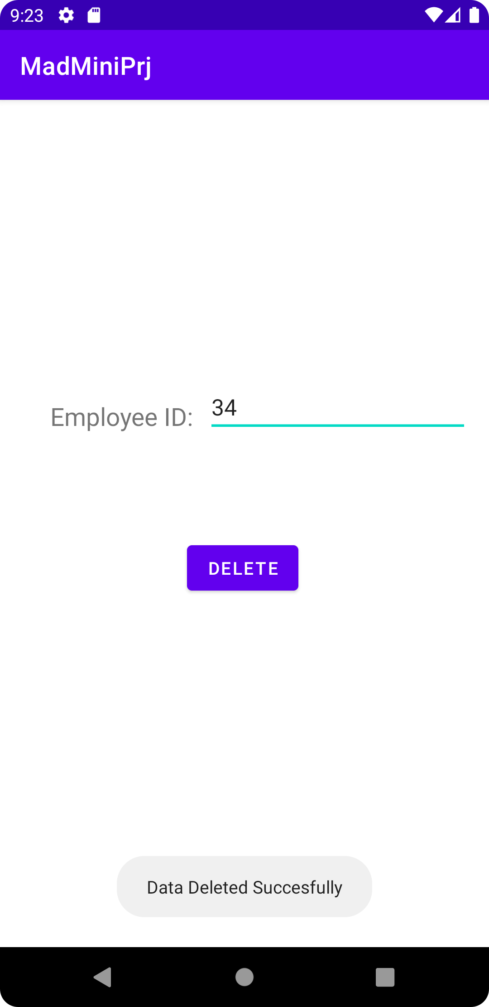

**Delete Page Successful Deletion**

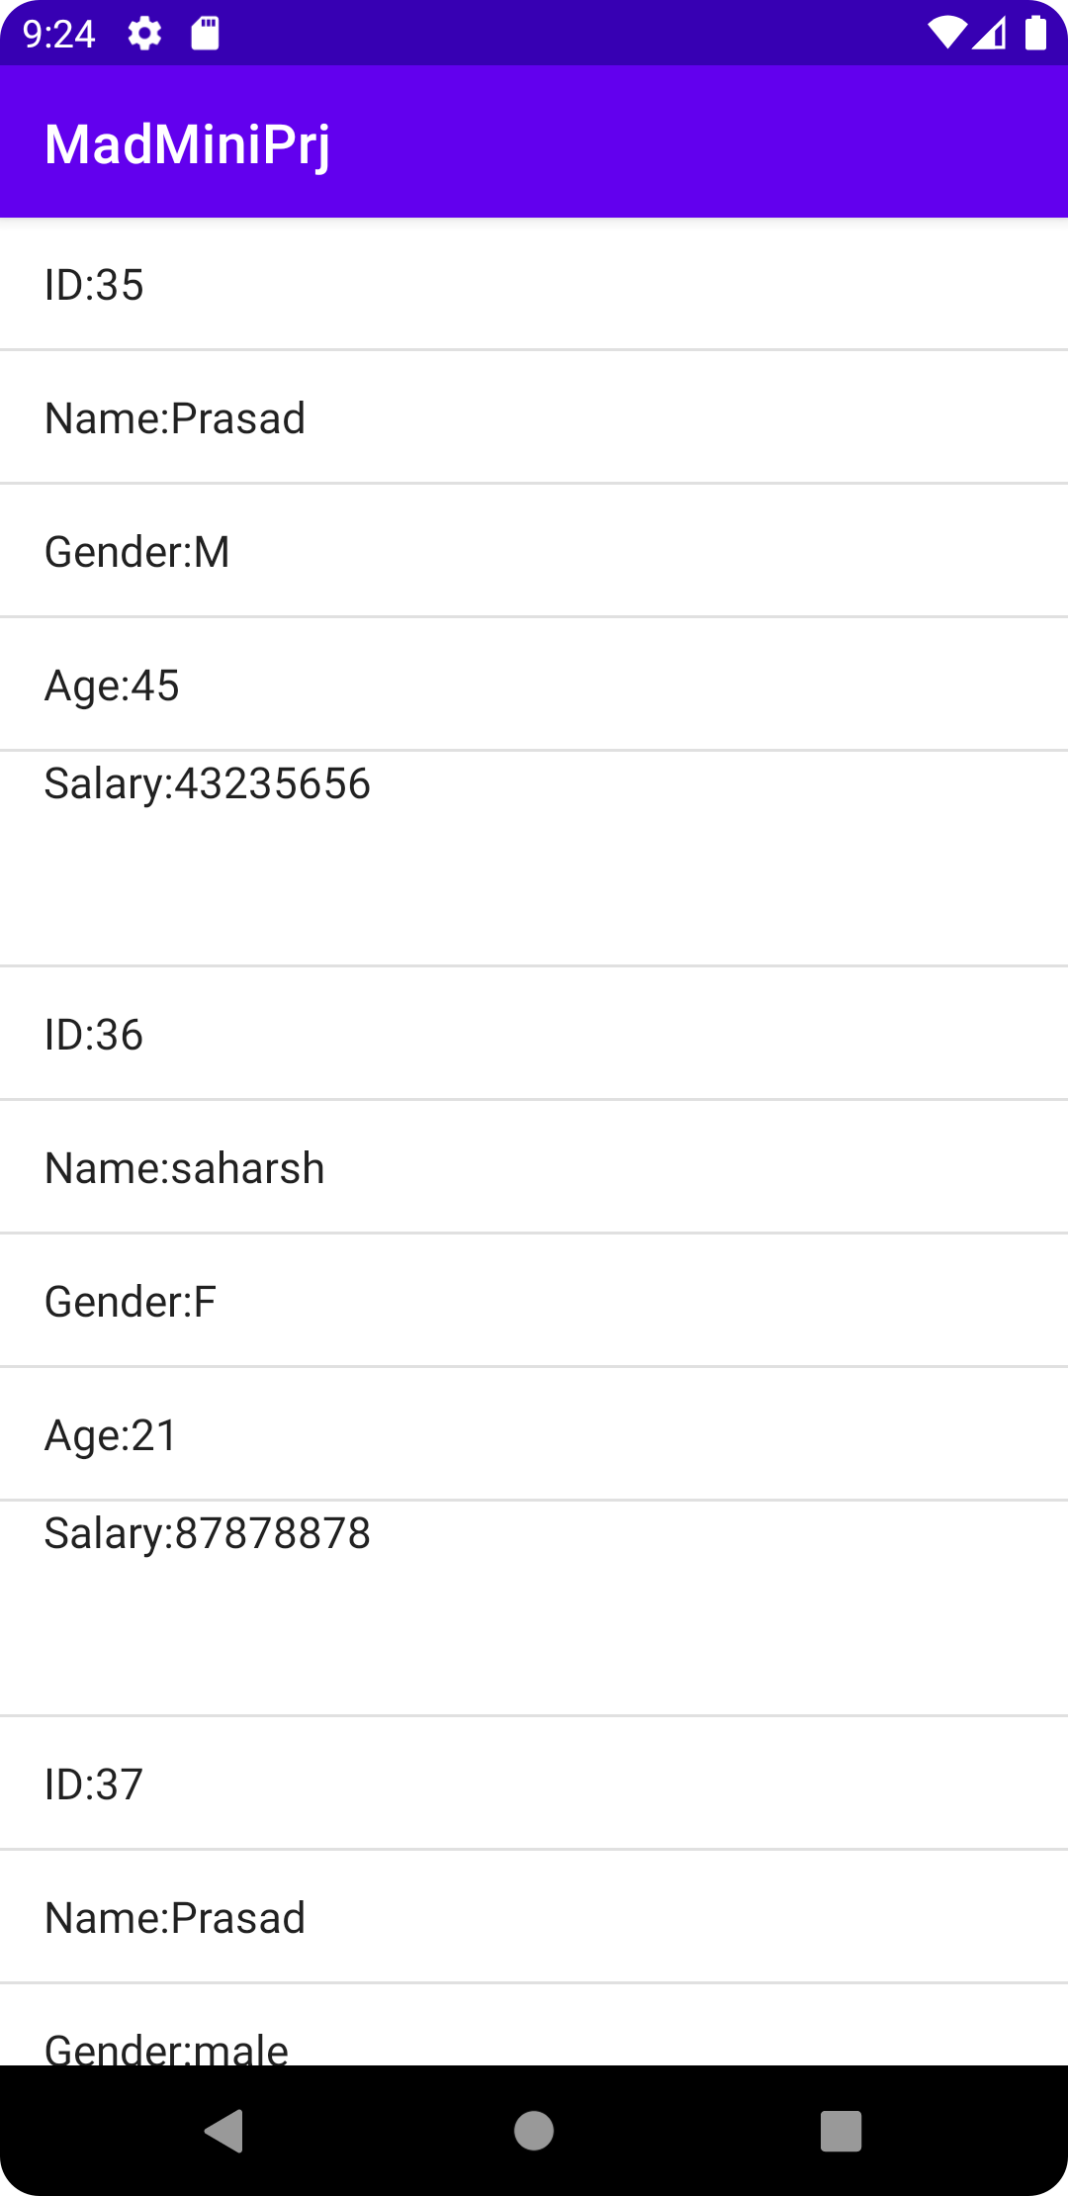 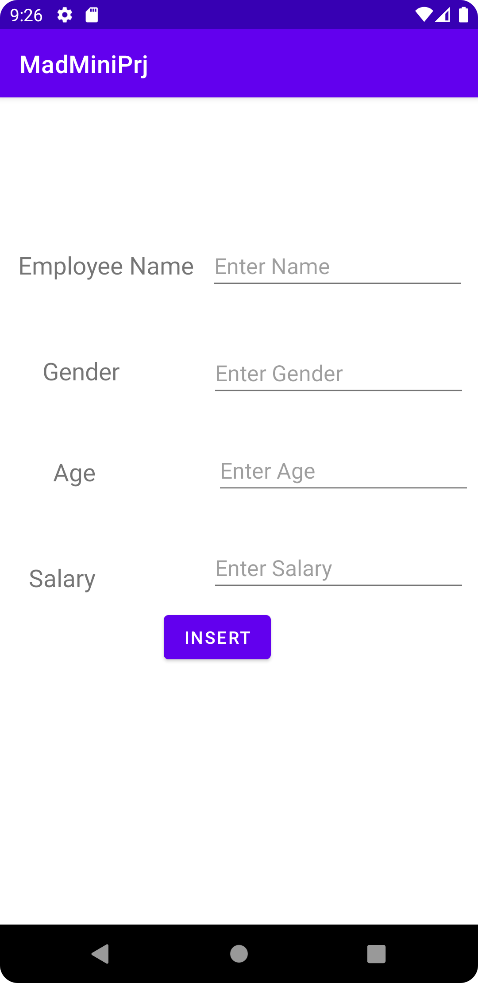

**ListView of all the Employees Insert Page**